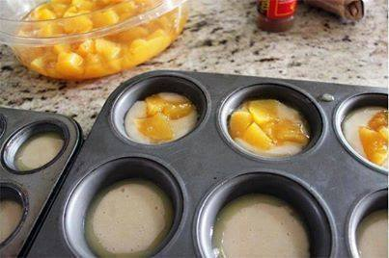

MINI PEACH COBBLERS
Ingredients:
1 cup sugar
1 cup flour
2 tsp baking powder
a dash of salt
3/4 cup milk
1 stick of melted butter
brown sugar
cinnamon
1 can diced peaches
Directions:
Preheat oven to 350˚F.
Put 1 tsp of melted butter into each regular size muffin tin.
Combine the first 5 ingredients by hand… sugar, flour, baking powder, salt and milk.
Put 2 tbsp of batter into each regular size muffin tin… on top of the melted butter.
Then put 1 tbsp diced peaches on top of the batter.
Sprinkle with brown sugar and then cinnamon.
Bake the regular size muffin tins for 12 minutes. Let them cool almost completely before taking out of pan.
Enjoy!
October 25, 2017

