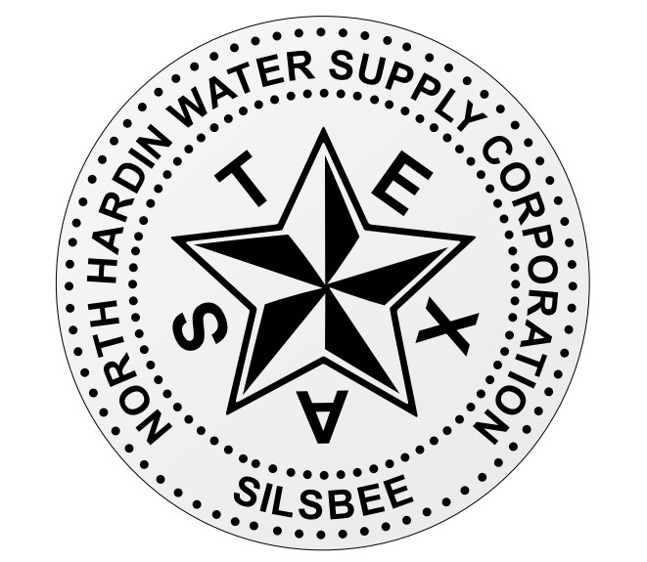

# *NORTH HARDIN WATER SUPPLY CORPORATION*

*BOBBY L. ROGERS*

*MANAGER*

## *P.O. BOX 55*

*SILSBEE, TEXAS 77656*

### *Phone: (409) 385-7355 Fax: (409) 385-0296*

**Boil Water Notice for Community Public Water Systems**

**01/10/25**

Due to reduced distribution system pressure caused by damage to our water main, the Texas Commission on Environmental Quality has required the North Hardin Water Supply Corporation public water system to notify all customers in the Southwest quadrant of the system which boarders from FM Hwy 1122 on the north and proceeding southwest along FM 418 eastward to FM Hwy 92 North. . People in this southwest quadrant should boil their water prior to consumption (e.g., washing hands/face, brushing teeth, drinking, etc). Children, seniors, and persons with weakened immune systems are particularly vulnerable to harmful bacteria, and all customers should follow these directions).

To ensure destruction of all harmful bacteria and other microbes, water for drinking, cooking, and ice making should be boiled and cooled prior to use for drinking water or human consumption purposes. The water should be brought to a vigorous rolling boil and then boiled for two minutes.

In lieu of boiling, individuals may purchase bottled water or obtain water from some other suitable source for drinking water or human consumption purposes.

When it is no longer necessary to boil the water, the public water system officials will notify customers that the water is safe for drinking water or human consumption purposes.

Once the boil water notice is no longer in effect, the public water system will issue a notice to customers that rescinds the boil water notice in a manner similar to this notice.

Please share this information with all the other people who drink this water, especially those who may not have received this notice directly (for example, people in apartments, nursing homes, schools, and businesses). You can do this by posting this notice in a public place or distributing copies by hand or mail.

If you have questions concerning this matter, you may contact North Hardin Water Supply Corporation at 409 385 7355. Crews are currently out making repairs to the system. We look to have this repaired very shortly.