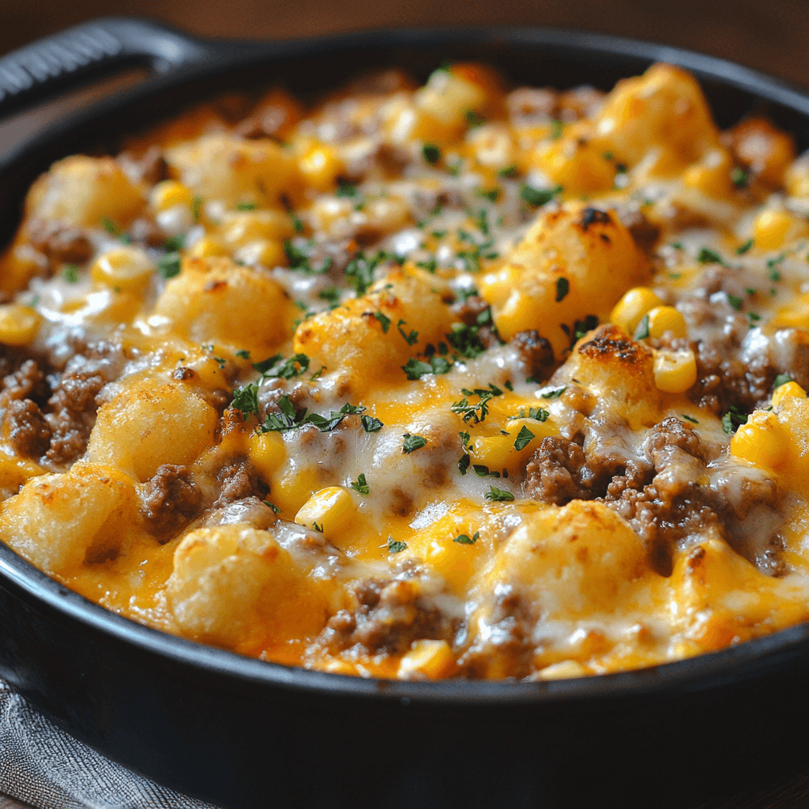**Cowboy Casserole**

* 1 pound ground beef
* 1 medium onion, diced
* 2 cloves garlic, minced
* 1 can (10.5 ounces) cream of mushroom soup
* 1/2 cup sour cream
* 1/2 cup milk
* 1 cup shredded cheddar cheese, divided
* 1 cup frozen or canned corn (drained)
* 1 teaspoon smoked paprika
* 1/2 teaspoon garlic powder
* 1/2 teaspoon salt
* 1/4 teaspoon black pepper
* 1 package (32 ounces) frozen tater tots

1. **Preheat and Prepare:** Preheat your oven to 375°F (190°C). Lightly grease a 9×13-inch baking dish and set it aside.
2. **Cook the Beef Mixture:** In a large skillet over medium heat, cook the ground beef until browned and crumbled. Drain any excess fat. Add the diced onion and minced garlic, cooking until softened (about 3 minutes). Remove the skillet from the heat.
3. **Make the Sauce:** In a mixing bowl, combine the cream of mushroom soup, sour cream, and milk. Stir in the smoked paprika, garlic powder, salt, and pepper.
4. **Combine Ingredients:** Add the beef mixture, corn, and 1/2 cup of shredded cheddar cheese to the bowl with the sauce. Mix until well combined.
5. **Assemble the Casserole:** Spread the beef mixture evenly into the prepared baking dish. Arrange the frozen tater tots in a single layer on top.
6. **Bake:** Bake the casserole for 25-30 minutes. Sprinkle the remaining 1/2 cup of shredded cheese on top and bake for an additional 5 minutes, or until the cheese is melted and bubbly.
7. **Cool and Serve:** Let the casserole cool slightly before serving. Garnish with fresh parsley or green onions, if desired.